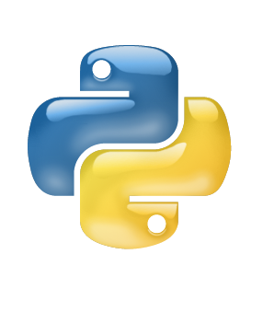

Python

Loop

Lab

Tutorial

Class IX

Lab 13

1. Print 1 to 100 using for loop
2. Print 1 to 50 using while loop
3. Create a dictionary with the item of tomato, potato, onion, cucumber. Print all of your item using for loop
4. Use range function to print 1 to 20
5. Use range function to print 1 to 30, if program founds 15 it will break the statement.